AWS Documentation : <https://docs.aws.amazon.com/index.html>

Create AWS Free tier A/C:-

<https://aws.amazon.com/free/?all-free-tier.sort-by=item.additionalFields.SortRank&all-free-tier.sort-order=asc>



Choose 12 months

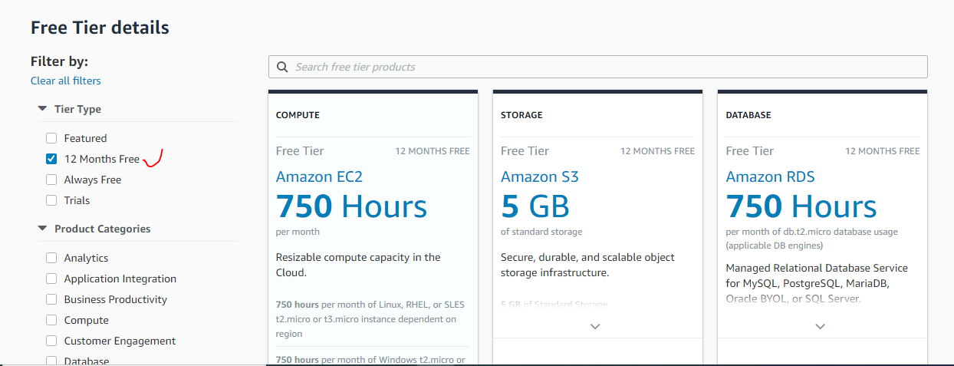

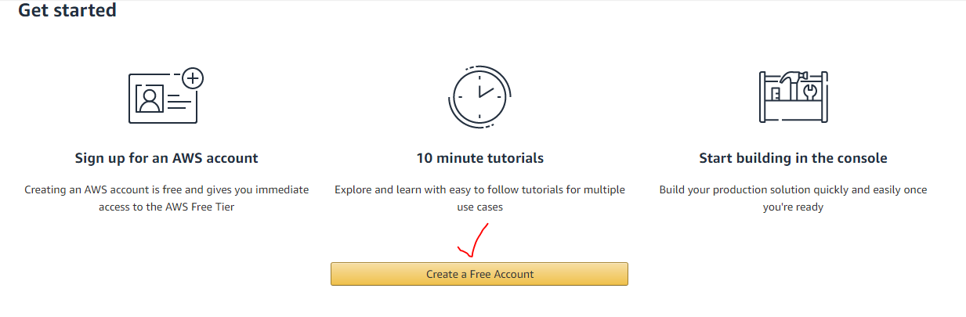

While create AWS account follow below steps:-

1.Valid Email Id

2. Valid mobile No with bank account linked

3. Valid credit or debit card for validation (here 2rs will deduct and again will credit in few days)

AWS account will activate in 24 hrs to 48 hrs.

Step1:-

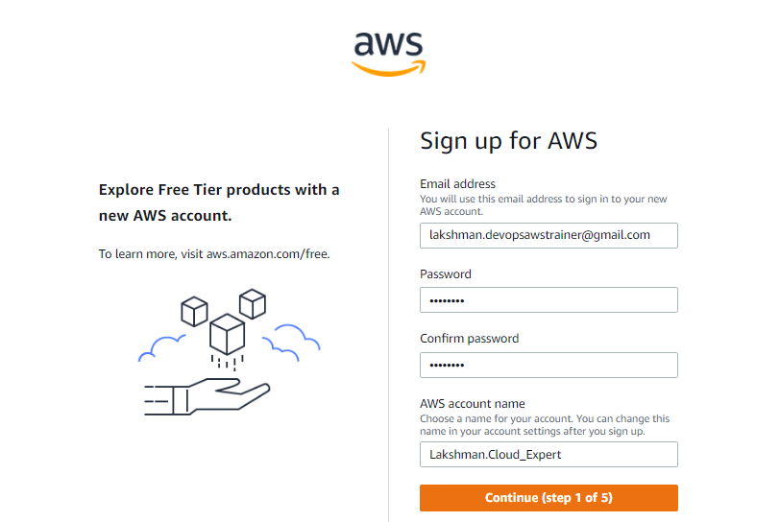

Step2:-

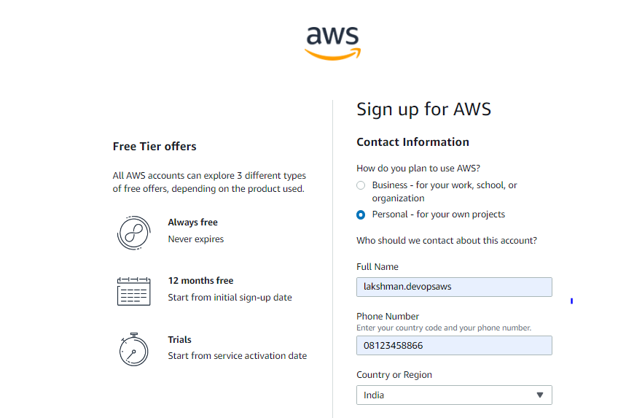

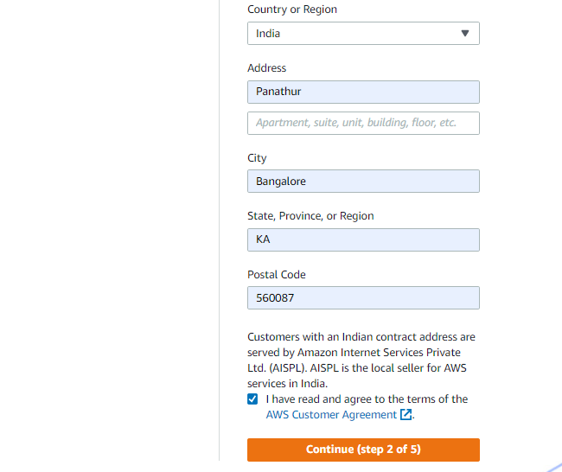

Step3:-

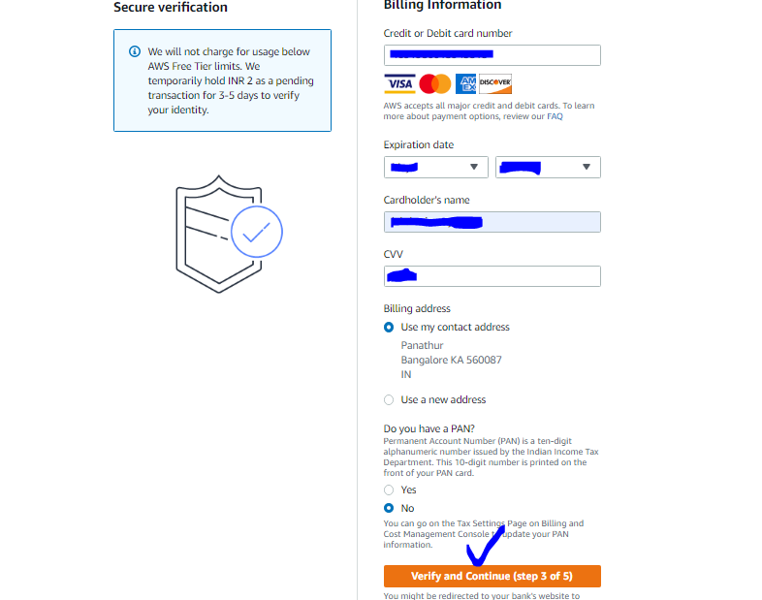

Note: will get OTP and deducted RS.2 INR for bank testing , will be return back 2rs asap.

Step4:- mobile OTP conformation

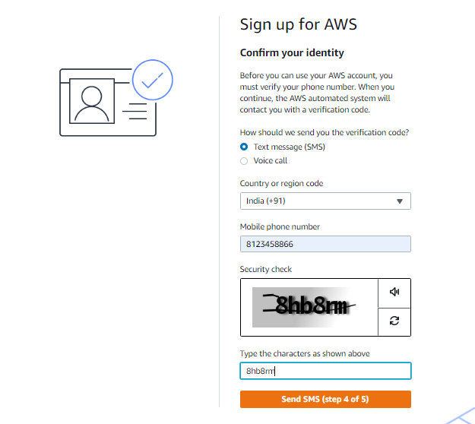

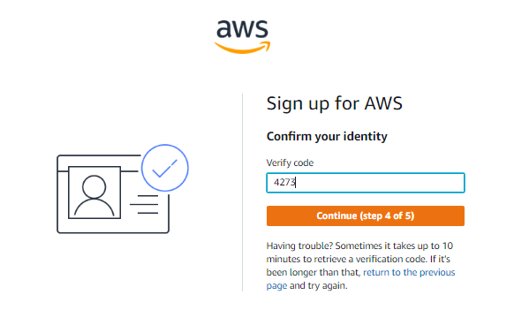

Step5:- choose basic support free style

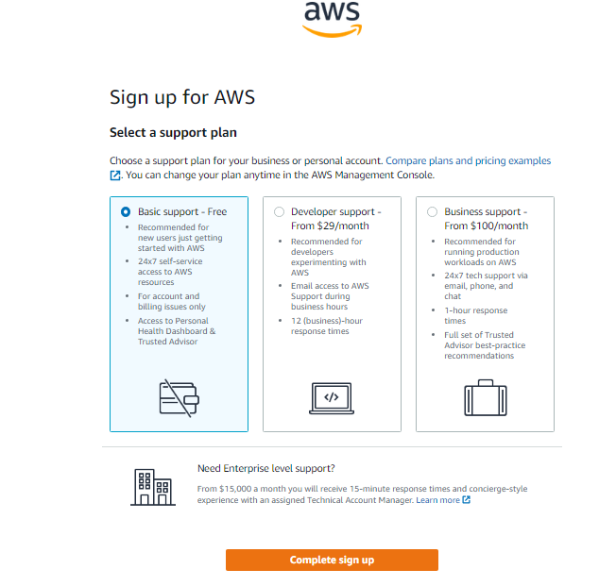

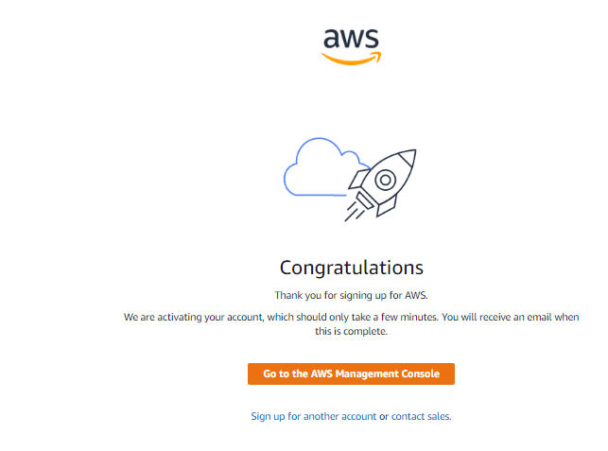

Click EC2 service.

**EC2 Creation:-**

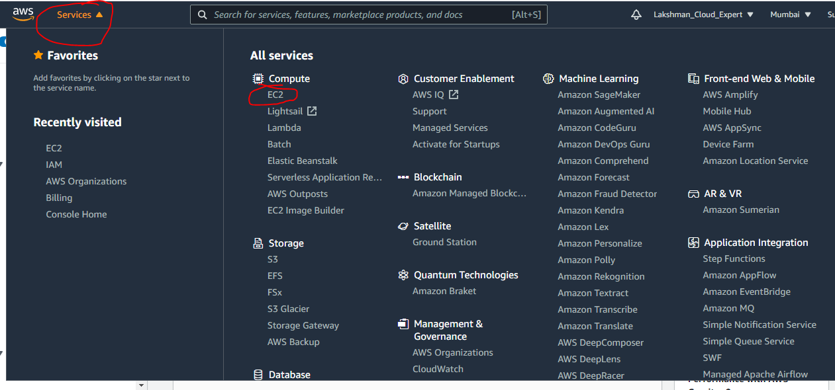

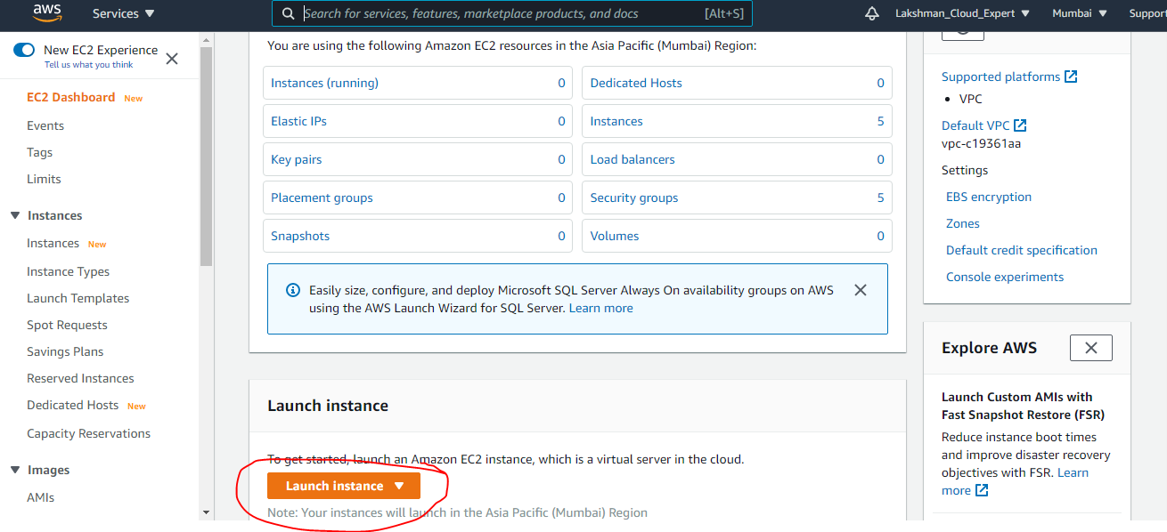

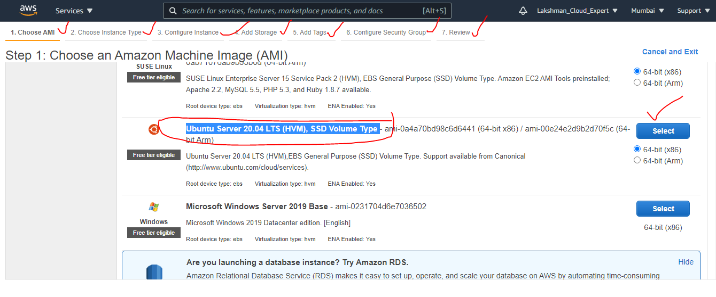

Choose Free tier – Linux/Ubuntu OS

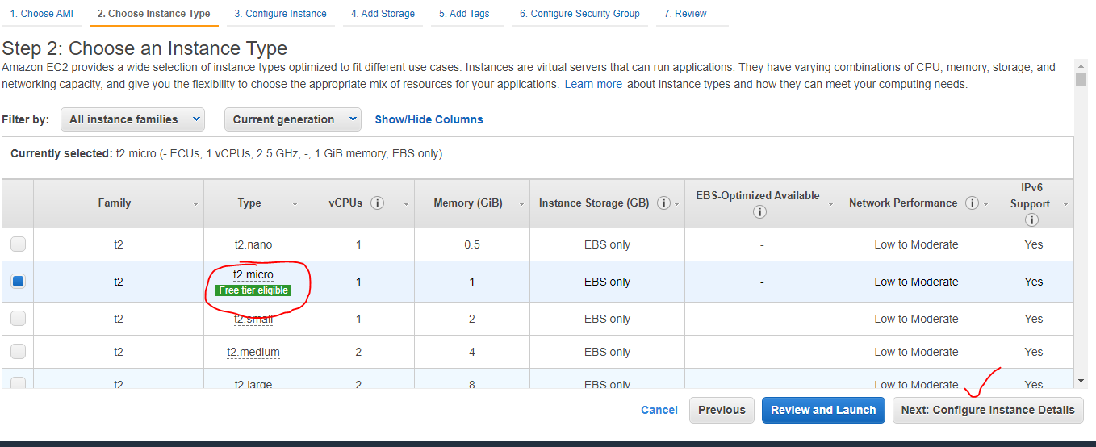

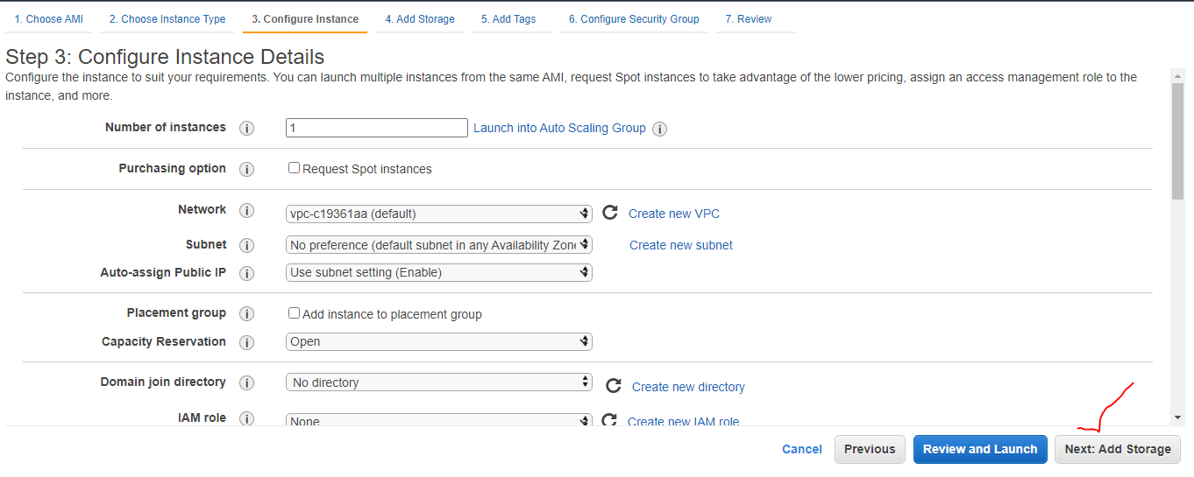

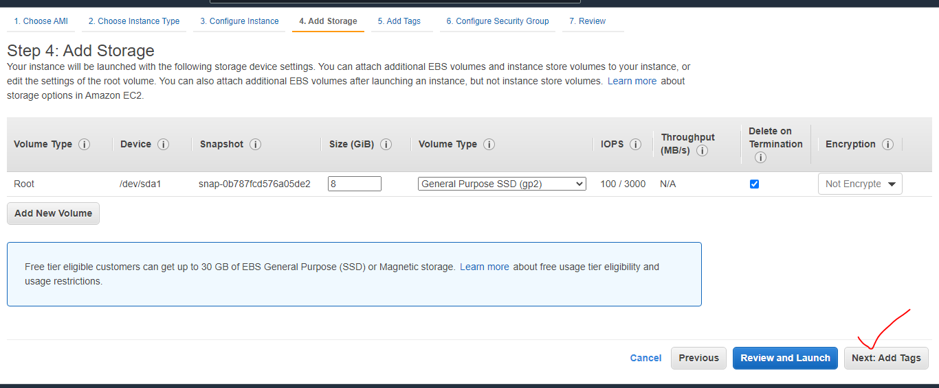

Give key- server, value any thing

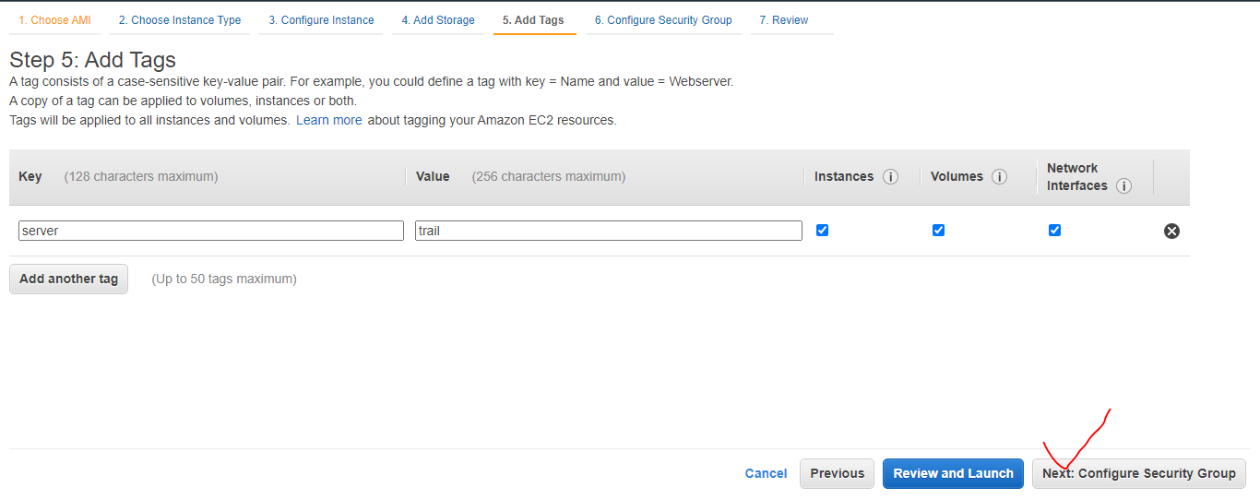

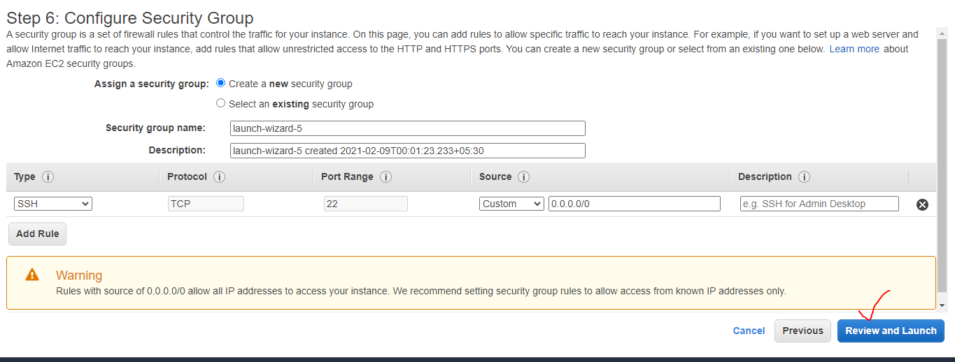

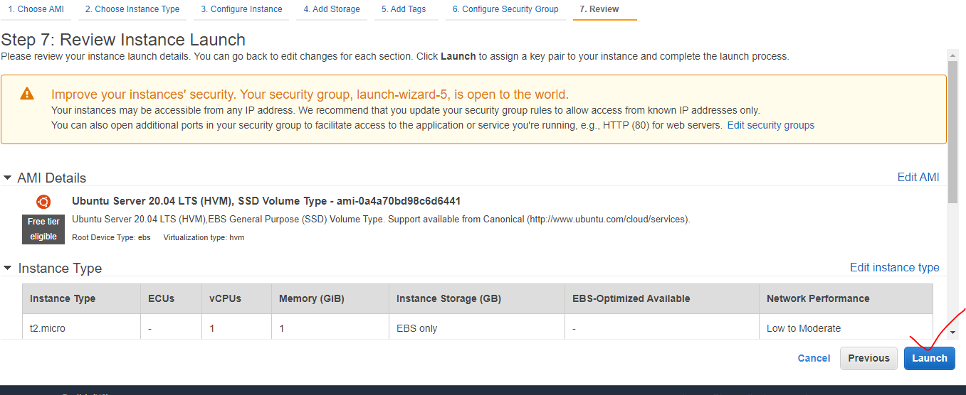

Choose create a new par as a first time, give any key pay name-> download key pair

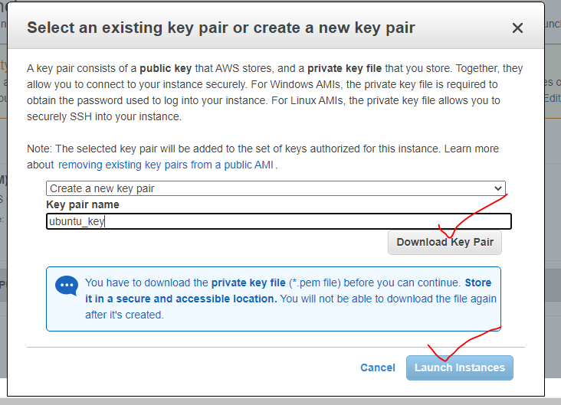

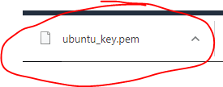

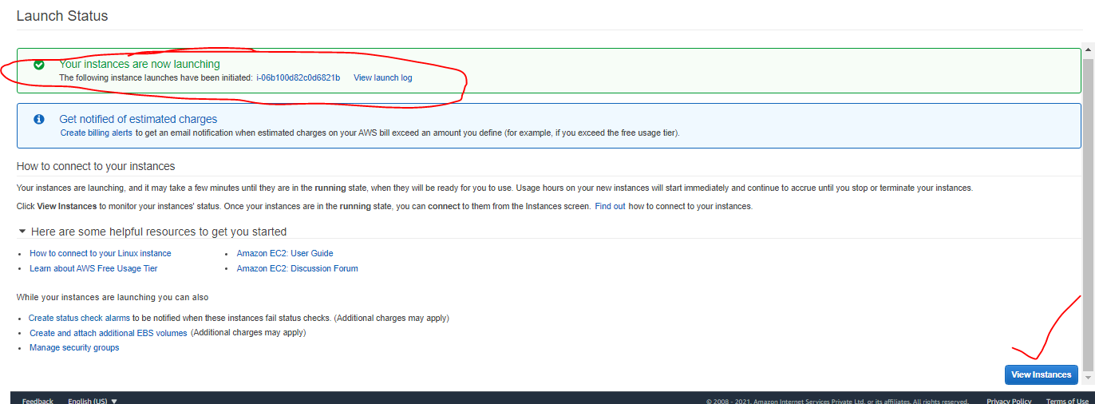

Install Putty Key Gen software :

<https://www.puttygen.com/download-putty>

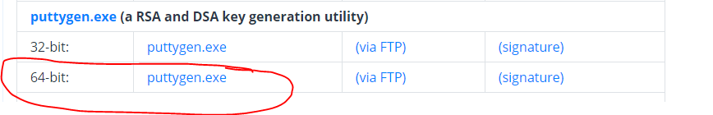



Double click and Click load

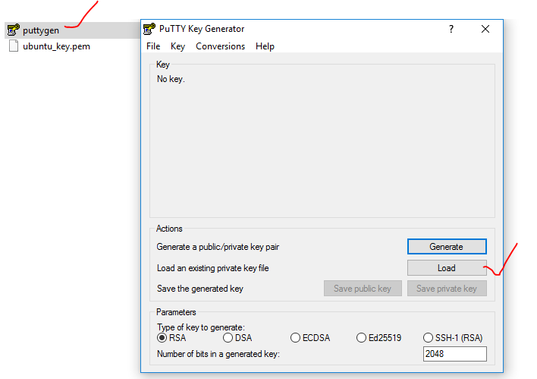

Choose already downloaded pem file from EC2 pair.

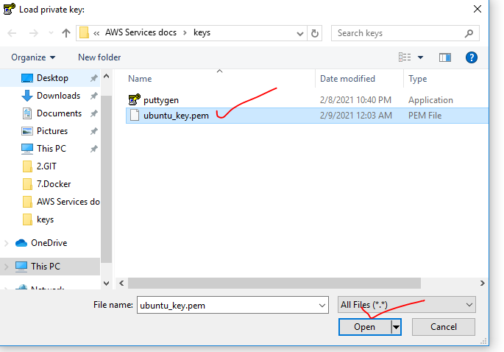

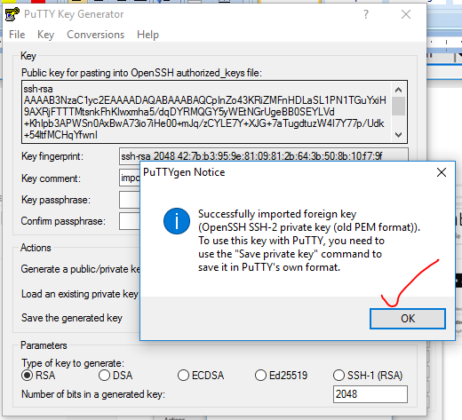

Ppk file is generated

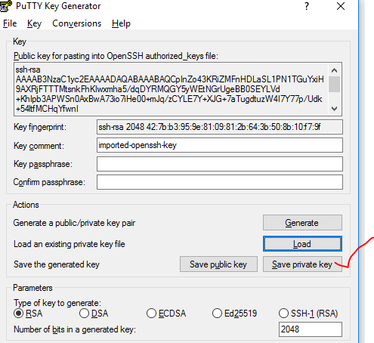

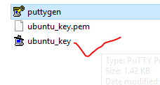

1 instance is created

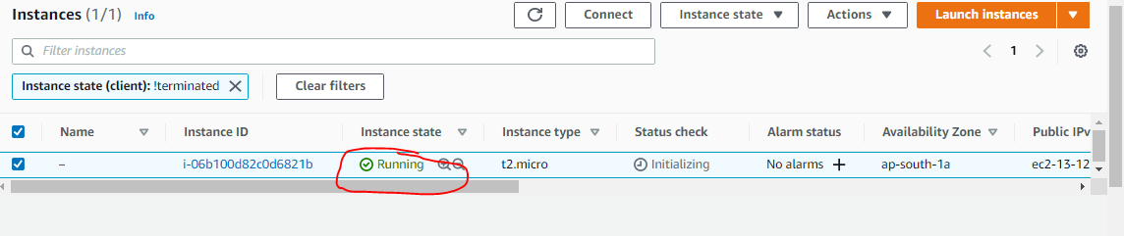

Rename instance name

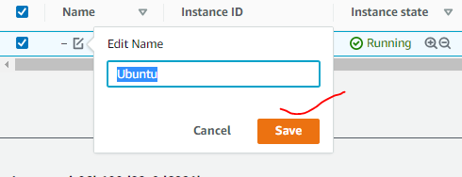

Take public IP address

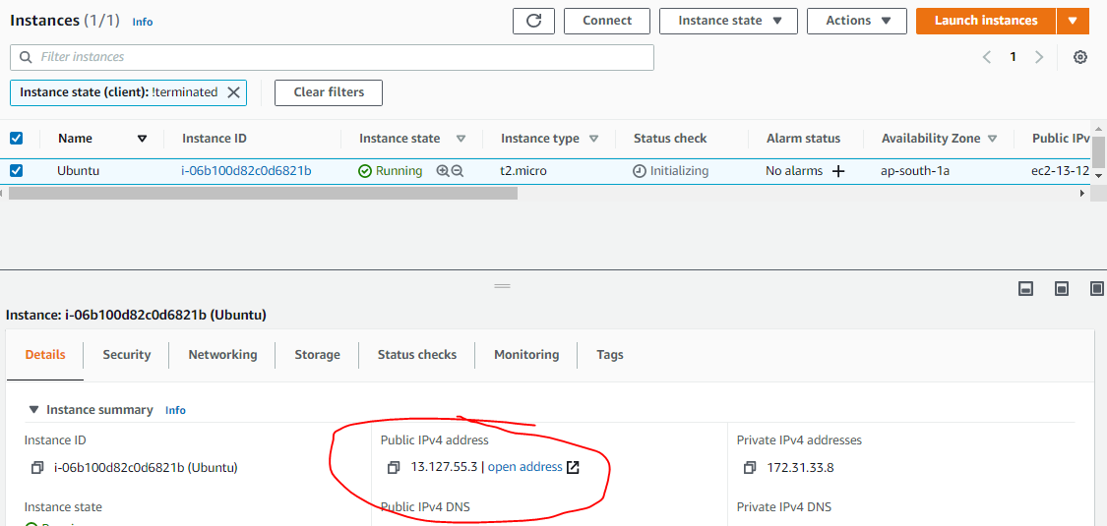

Open putty and copy public IP

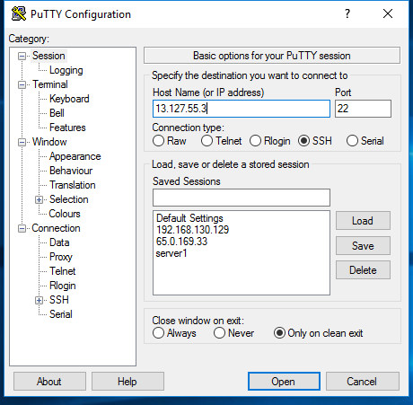

Click connection->SSH->Auth-> choose ppk file->open

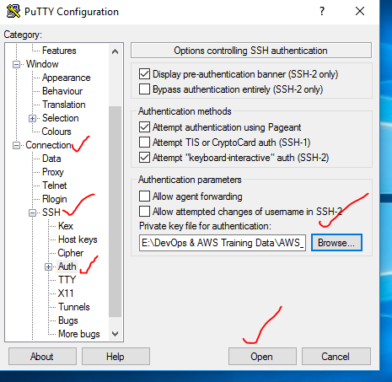

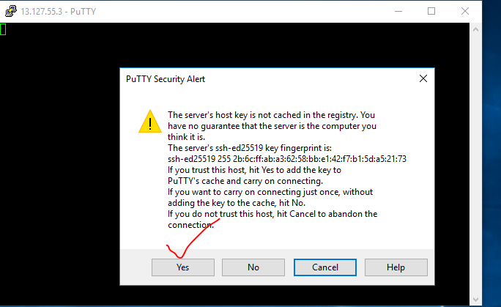

Provide by default un: ubuntu (not required any pwd)

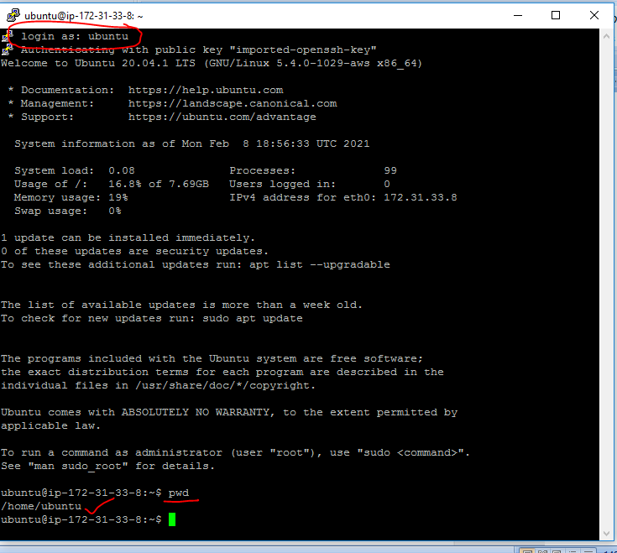

Access to root user

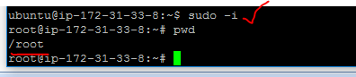

Strop server->right click instance state->stop

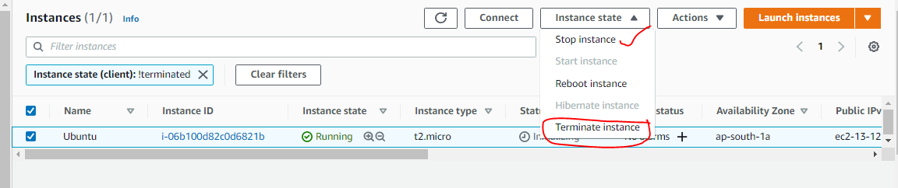

Better not using , we can terminate.

Note: -After restart the server will change your server public IP address (private IP address will not change)

=========================================EC2 END=====================================